**Employee Performance Index**

1. Create a database named project and employee, then import data_science_team.csv and proj_table.csv into the project database and emp_record_table.csv into the employee database from the given resources.

**SQL code:**

CREATE DATABASE IF NOT EXISTS project;

**Output:**

The following output shows the imported tables in the database.

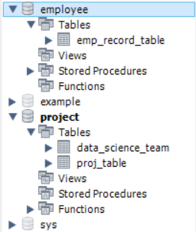

1. Create an ER diagram for the given **project** and the **employee** databases.

**Output:**

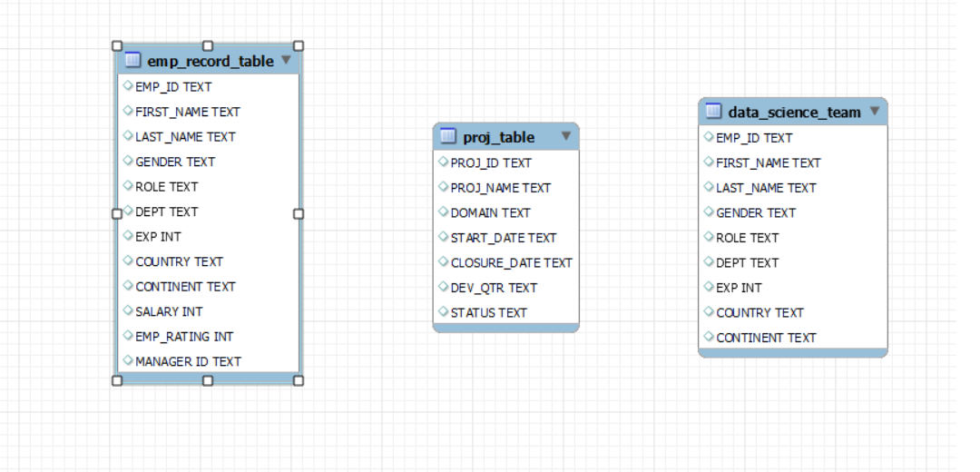

1. Write a query to fetch EMP_ID, FIRST_NAME, LAST_NAME, GENDER, and DEPARTMENT from the employee record table, and make a list of employees and details of their department.

**SQL code:**

SELECT EMP_ID, FIRST_NAME, LAST_NAME, GENDER, DEPT

FROM employee.emp_record_table;

**Output:**

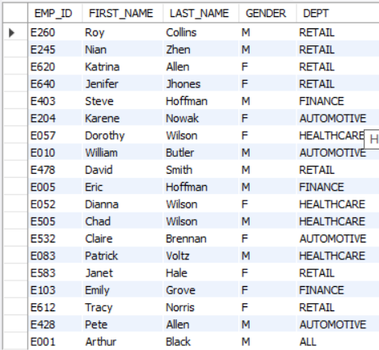

1. Write a query to fetch EMP_ID, FIRST_NAME, LAST_NAME, GENDER, DEPARTMENT, and EMP_RATING if the EMP_RATING is:

* less than two
* greater than four
* between two and four

**SQL code:**

SELECT EMP_ID, FIRST_NAME, LAST_NAME, GENDER, DEPT, EMP_RATING

FROM employee.emp_record_table

WHERE EMP_RATING < 2;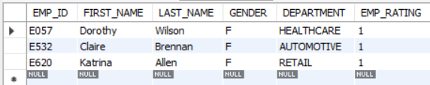

SELECT EMP_ID, FIRST_NAME, LAST_NAME, GENDER, DEPT, EMP_RATING

FROM employee.emp_record_table

WHERE EMP_RATING between 2 and 4;

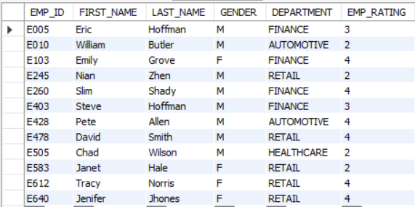

SELECT EMP_ID, FIRST_NAME, LAST_NAME, GENDER, DEPT, EMP_RATING  
FROM employee.emp_record_table  
WHERE EMP_RATING > 4;

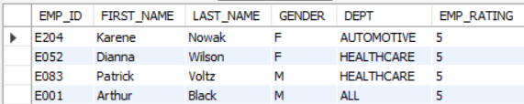

1. Write a query to concatenate the FIRST_NAME and the LAST_NAME of employees in the Finance department from the employee table and then give the resultant column alias as NAME.

**SQL code:**

SELECT CONCAT_WS(' ', FIRST_NAME, LAST_NAME) AS `NAME`

FROM employee.emp_record_table

WHERE DEPT = "FINANCE";

**Output:**

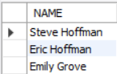

1. Write a query to list only those employees who have someone reporting to them. Also, show the number of reporters (including the President).

**SQL code:**

SELECT

m.EMP_ID, m.FIRST_NAME, m.LAST_NAME, m.ROLE,

m.EXP, m.DEPT, COUNT(e.EMP_ID) as "EMP_COUNT"

FROM

employee.emp_record_table m

INNER JOIN employee.emp_record_table e

ON m.EMP_ID = e.MANAGER_ID

AND e.EMP_ID != e.MANAGER_ID

WHERE m.ROLE IN ("MANAGER", "PRESIDENT", "CEO")

GROUP BY m.EMP_ID

ORDER BY m.EMP_ID;

**Output:**

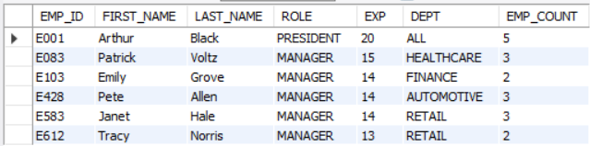

1. Write a query to list down all the employees from the healthcare and finance department using union. Take data from the employee record table.

**SQL code:**

SELECT e.EMP_ID as ID,

CONCAT(e.FIRST_NAME,' ',e.LAST_NAME) AS `NAME`,

e.DEPT

FROM employee.emp_record_table e

WHERE e.DEPT IN ("HEALTHCARE")

UNION

SELECT e.EMP_ID as ID,

CONCAT(e.FIRST_NAME,' ',e.LAST_NAME) AS `NAME`,

e.DEPT

FROM employee.emp_record_table e

WHERE e.DEPT IN ("FINANCE")

ORDER BY DEPT, ID;

**Output:**

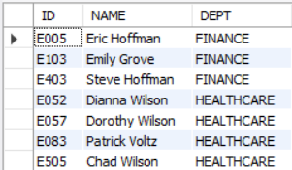

1. Write a query to list down employee details such as EMP_ID, FIRST_NAME, LAST_NAME, ROLE, DEPARTMENT, and EMP_RATING grouped by dept. Also include the respective employee rating along with the max emp rating for the department.

**SQL code:**

SELECT EMP_ID, FIRST_NAME, LAST_NAME, ROLE, DEPT, EMP_RATING, MAX(EMP_RATING)

OVER (PARTITION BY DEPT) AS MAX_EMP_RATING

FROM employee.emp_record_table;

**Output:**

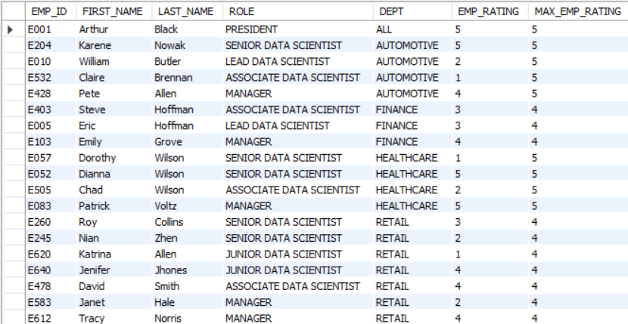

1. Write a query to calculate the minimum and the maximum salary of the employees in each role. Take data from the employee record table.

**SQL code:**

SELECT DISTINCT(ROLE), MAX(SALARY)

OVER (PARTITION BY ROLE) MAX_SALARY, MIN(SALARY)

OVER (PARTITION BY ROLE) MIN_SALARY

FROM employee.emp_record_table;

**Output:**

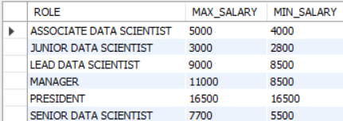

1. Write a query to assign ranks to each employee based on their experience. Take data from the employee record table.

**SQL code:**

SELECT EMP_ID, FIRST_NAME, LAST_NAME, DEPT, EXP,

RANK() OVER (ORDER BY EXP) EXP_RANK,

DENSE_RANK() OVER (ORDER BY EXP) EXP_DENSE_RANK

FROM employee.emp_record_table;

**Output:**

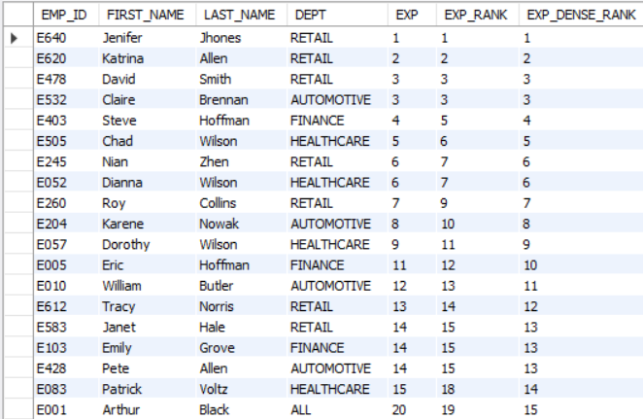

1. Write a query to create a view that displays employees in various countries whose salary is more than six thousand. Take data from the employee record table.

**SQL code:**

CREATE VIEW Employee_View

AS

SELECT EMP_ID, FIRST_NAME, LAST_NAME, COUNTRY, SALARY

FROM employee.emp_record_table

WHERE SALARY > 6000;

SELECT * FROM Employee_view;

**Output:**

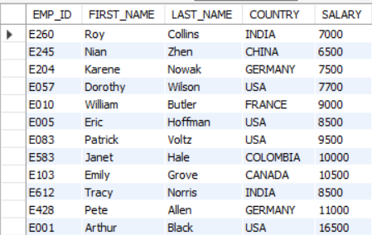

1. Write a nested query to find employees with experience of more than ten years. Take data from the employee record table.

**SQL code:**

SELECT EMP_ID, FIRST_NAME, LAST_NAME, GENDER, DEPT, ROLE, EXP

FROM employee.emp_record_table

WHERE ROLE IN (SELECT ROLE FROM employee.emp_record_table HAVING EXP >10);

**Output:**

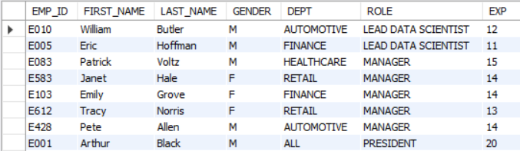

1. Write a query to create a stored procedure to retrieve the details of the employees whose experience is more than three years. Take data from the employee record table.

**SQL code:**

DELIMITER &&

CREATE PROCEDURE experienced_personal()

BEGIN

SELECT EMP_ID, FIRST_NAME, LAST_NAME, GENDER, DEPT, ROLE, EXP

FROM employee.emp_record_table WHERE EXP > 3;

END &&

DELIMITER ;

call experienced_personal();

**Output:**

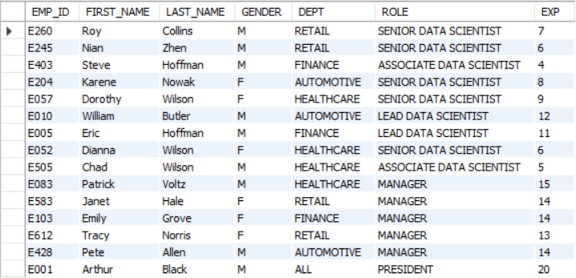

1. Write a query using stored functions in the project table to check whether the job profile assigned to each employee in the data science team matches the organization’s set standard.

The standard being:

For an employee with experience less than or equal to 2 years assign 'JUNIOR DATA SCIENTIST',

For an employee with the experience of 2 to 5 years assign 'ASSOCIATE DATA SCIENTIST',

For an employee with the experience of 5 to 10 years assign 'SENIOR DATA SCIENTIST',

For an employee with the experience of 10 to 12 years assign 'LEAD DATA SCIENTIST',

For an employee with the experience of 12 to 16 years assign 'MANAGER'.

**SQL code:**

DELIMITER $$

drop FUNCTION Employee_details;

CREATE FUNCTION Employee_details(EXP int)

RETURNS VARCHAR(255) DETERMINISTIC

BEGIN DECLARE Employee_details VARCHAR(255);

IF EXP <= 2 THEN SET Employee_details = 'JUNIOR DATA SCIENTIST';

ELSEIF EXP <= 5 THEN SET Employee_details = 'ASSOCIATE DATA SCIENTIST';

ELSEIF EXP <= 10 THEN SET Employee_details = 'SENIOR DATA SCIENTIST';

ELSEIF EXP <= 12 THEN SET Employee_details = 'LEAD DATA SCIENTIST';

ELSEIF EXP <= 16 THEN SET Employee_details = 'MANAGER';

END IF;

RETURN (Employee_details);

END$$

DELIMITER $$;

SELECT FIRST_NAME, LAST_NAME, DEPT, EXP, ROLE, Employee_details(EXP) as DESIGNATION

FROM employee.emp_record_table ORDER BY EXP;

**Output:**

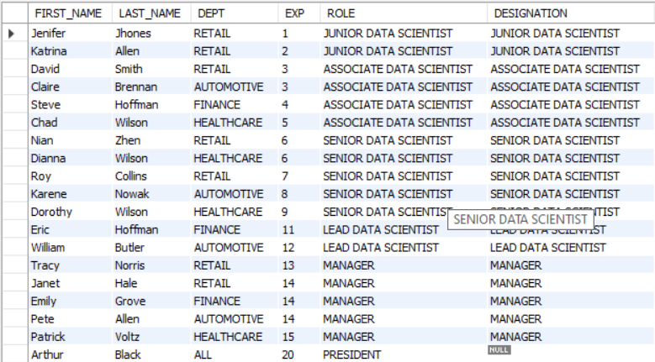

1. Create an index to improve the cost and performance of the query to find the employee whose FIRST_NAME is ‘Eric’ in the employee table after checking the execution plan.

**SQL code: Before Indexing**

SELECT *

FROM employee.emp_record_table

WHERE FIRST_NAME='Eric';

**Output:**



**SQL code: Indexing**

CREATE INDEX query1 ON employee.emp_record_table(FIRST_NAME);

SELECT *

FROM employee.emp_record_table

WHERE FIRST_NAME='Eric';

**Output:**



1. Write a query to calculate the bonus for all the employees, based on their ratings and salaries (Use the formula: 5% of salary * employee rating).

**SQL code:**

SELECT EMP_ID, FIRST_NAME, LAST_NAME, ROLE, SALARY, EMP_RATING, (SALARY/20)*EMP_RATING AS BONUS

FROM employee.emp_record_table;

**Output:**

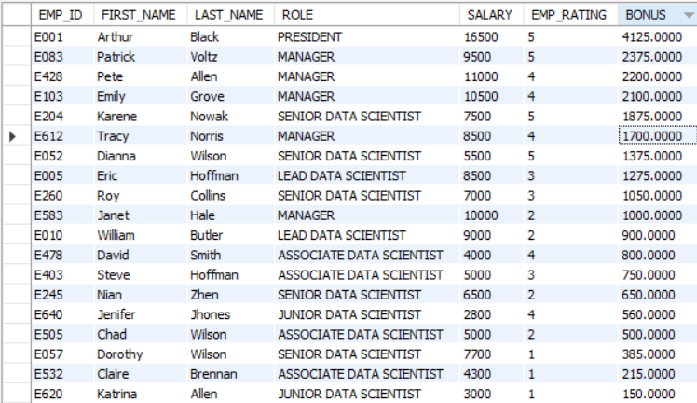

1. Write a query to calculate the average salary distribution based on the continent and country. Take data from the employee record table.

**SQL code:**

SELECT CONTINENT, COUNTRY, AVG(SALARY) as AVERAGE_SALARY

FROM employee.emp_record_table

GROUP BY CONTINENT, COUNTRY WITH ROLLUP;

**Output:**

